[Eden] Document workflow for "create project" Sahana Software Foundation
This particular Eden document workflow is simply a guide on how to create a project on the Sahana Software Foundation. Simply following the instructions below can help you, as an interested user, to create your own project on the Sahana Software Foundation. It is important to mention that you can only create a project in this software if you are logged in. If you don’t have an account, ensure you create one, it is very simple.
Further Details…
Instructions on how to create your project.
(In order to view the enlarged images of the below pictures, hold down the Ctrl key and click on the picture.)
- On the Sahana home page, click on the project button.
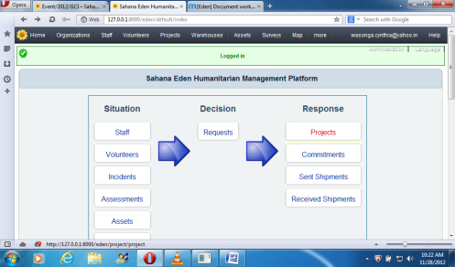
- Click on the “Add New Project” button in order to add a new project.
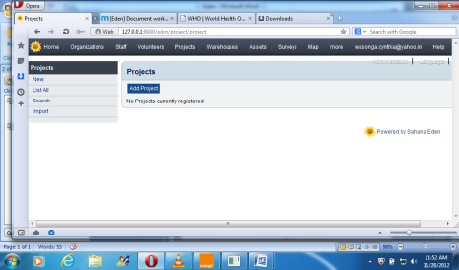
3.A page will appear that will require you to fill in the details of your project. Edit your project.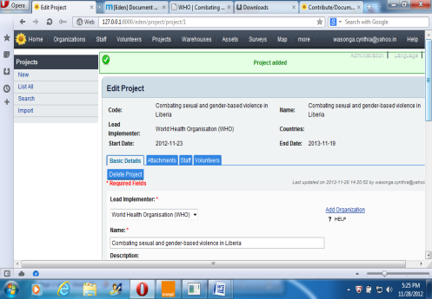
4. Save your project by clicking on the save button.
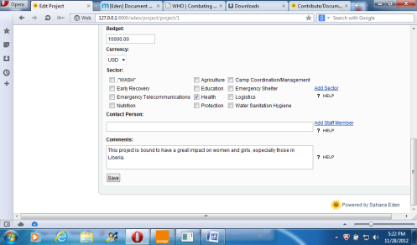
You will see a page confirming that your project has been updated.
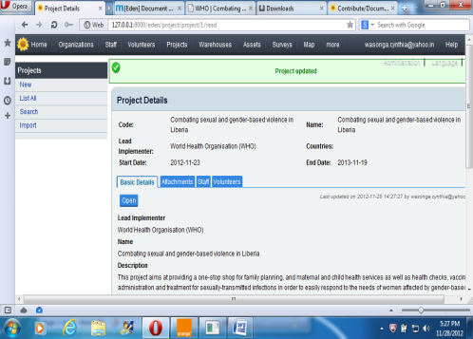
And there you have it!
Links to related workflows.
http://127.0.0.1:8000/eden/default/index
http://127.0.0.1:8000/eden/project/project

