- My task
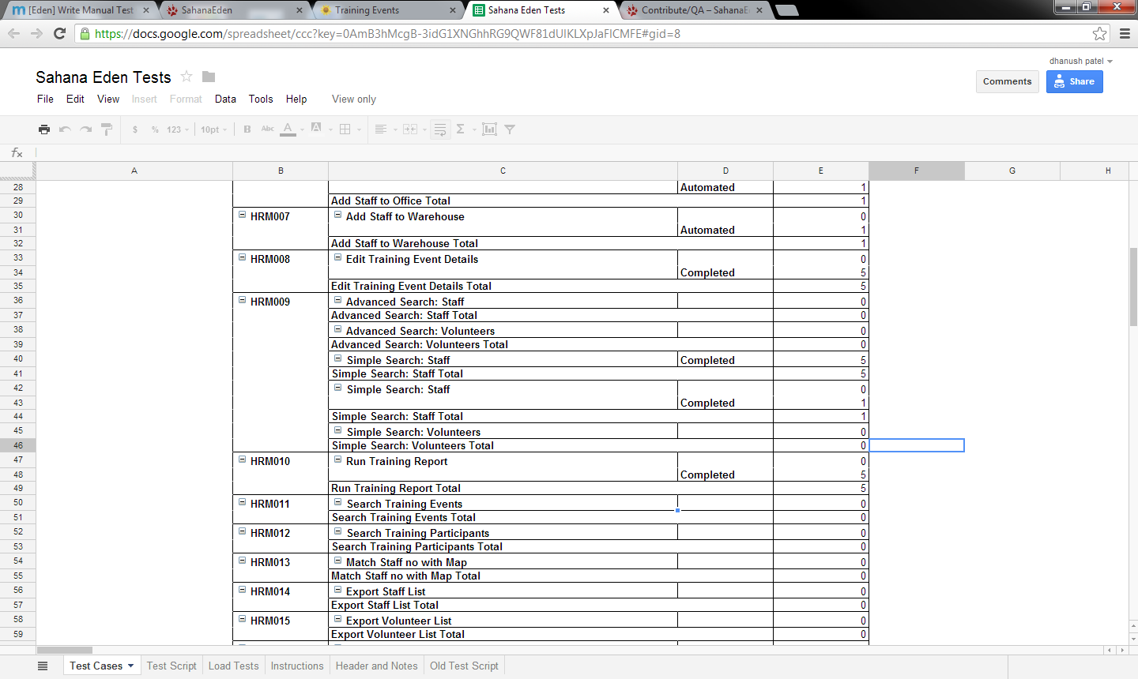
- Made 3 new training courses (Test1, Test2, Test3)
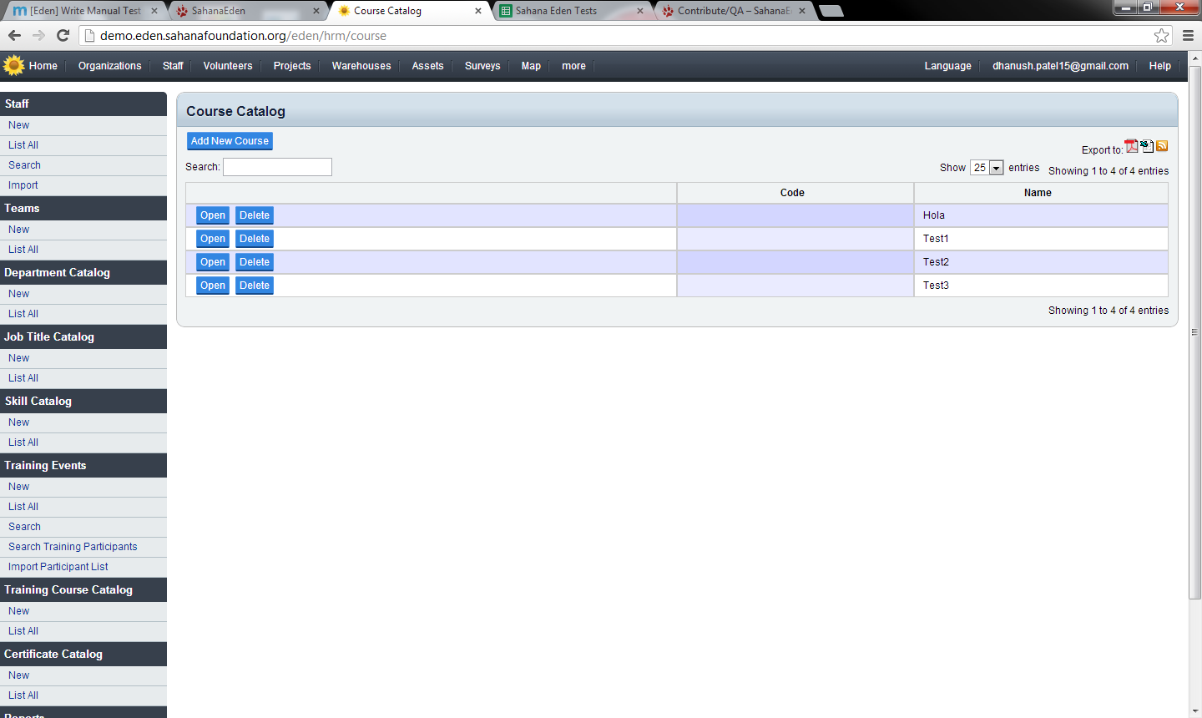

- Made 3 new training events, ( to clarify, both training event details and participants were saved properly, however participants were shown un-saved to show all detail), the training event details and then the participants are shown for all training events
  - 1st training event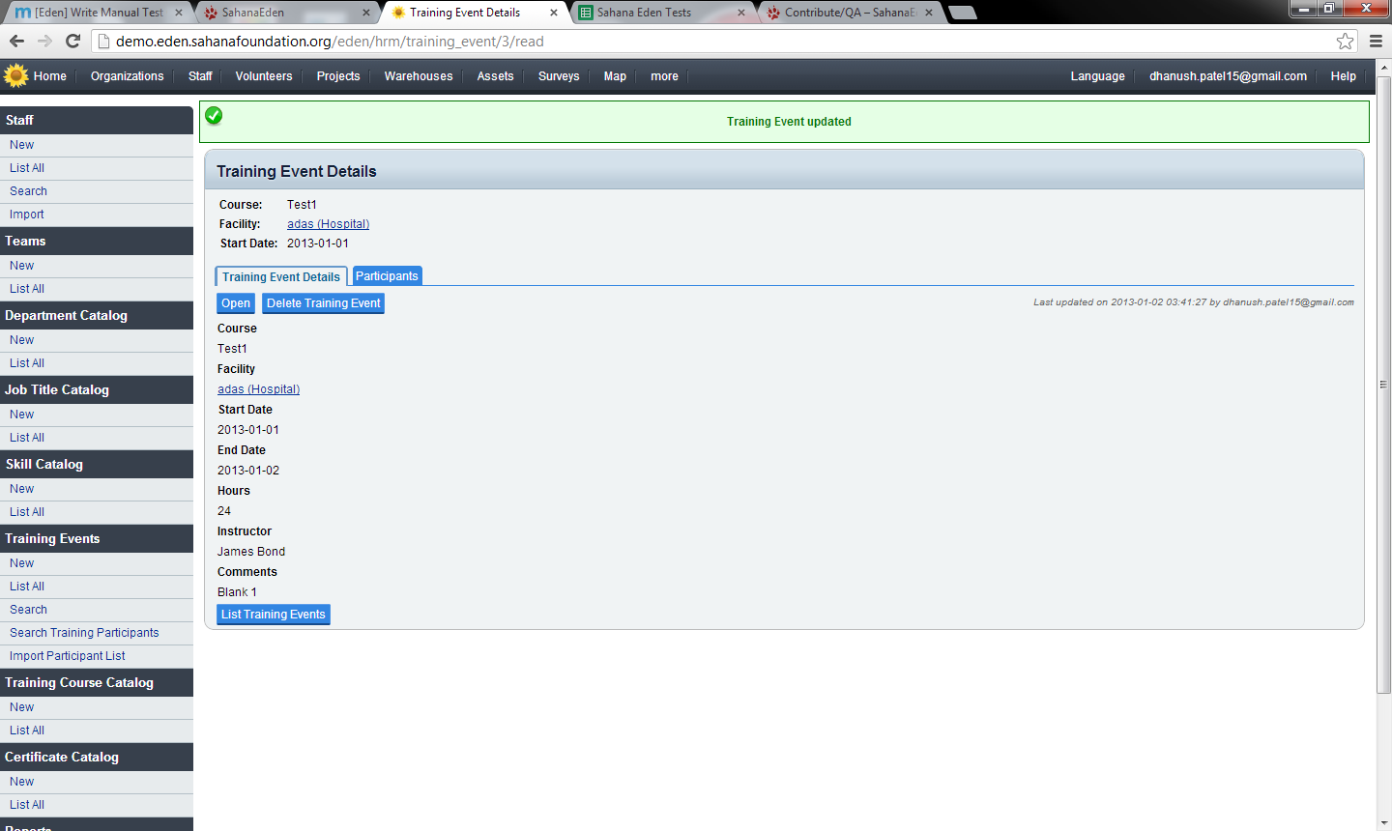
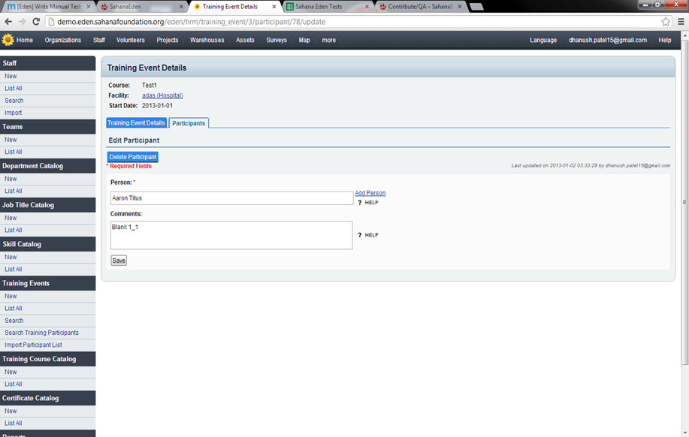
  - 2nd training event
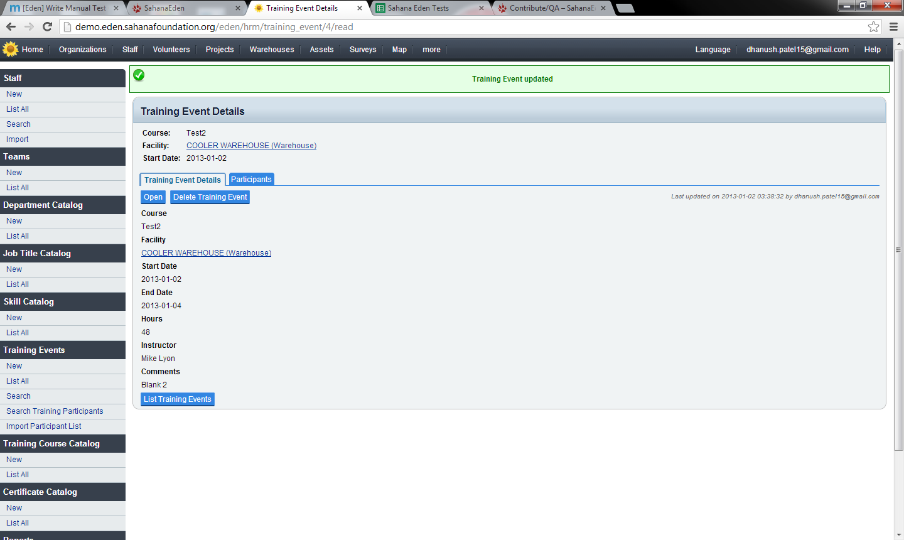
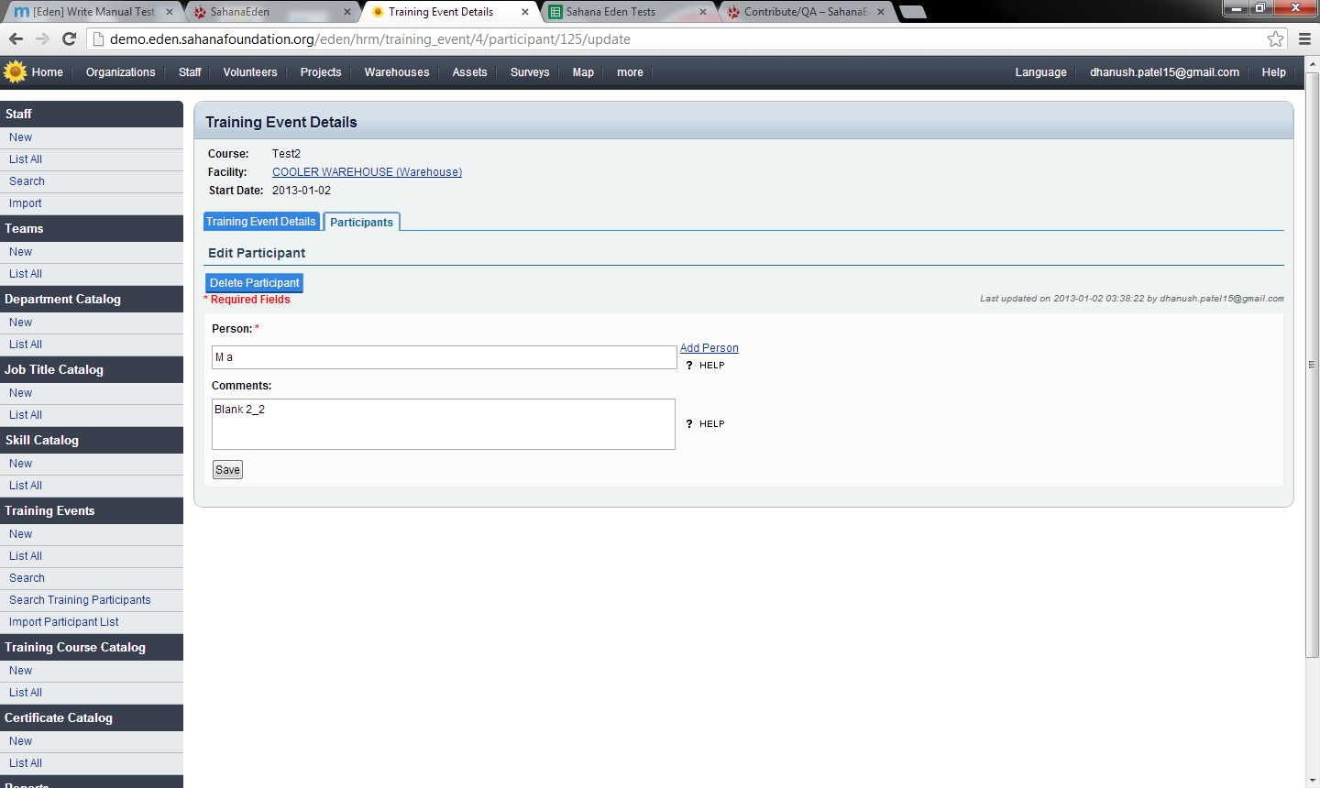
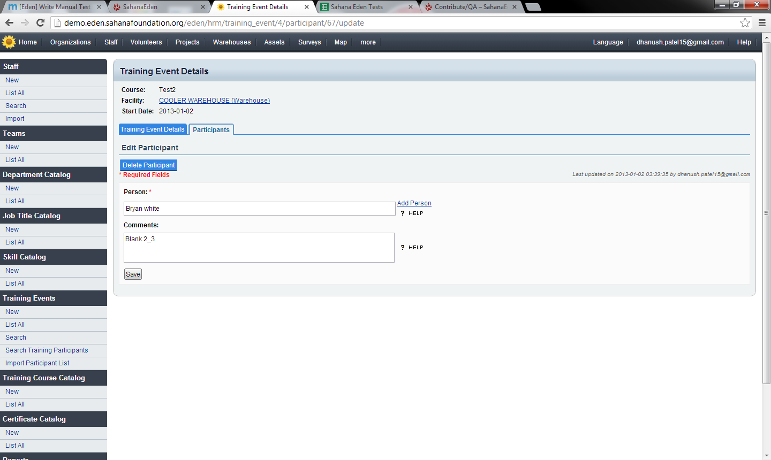

  - 3rd training event
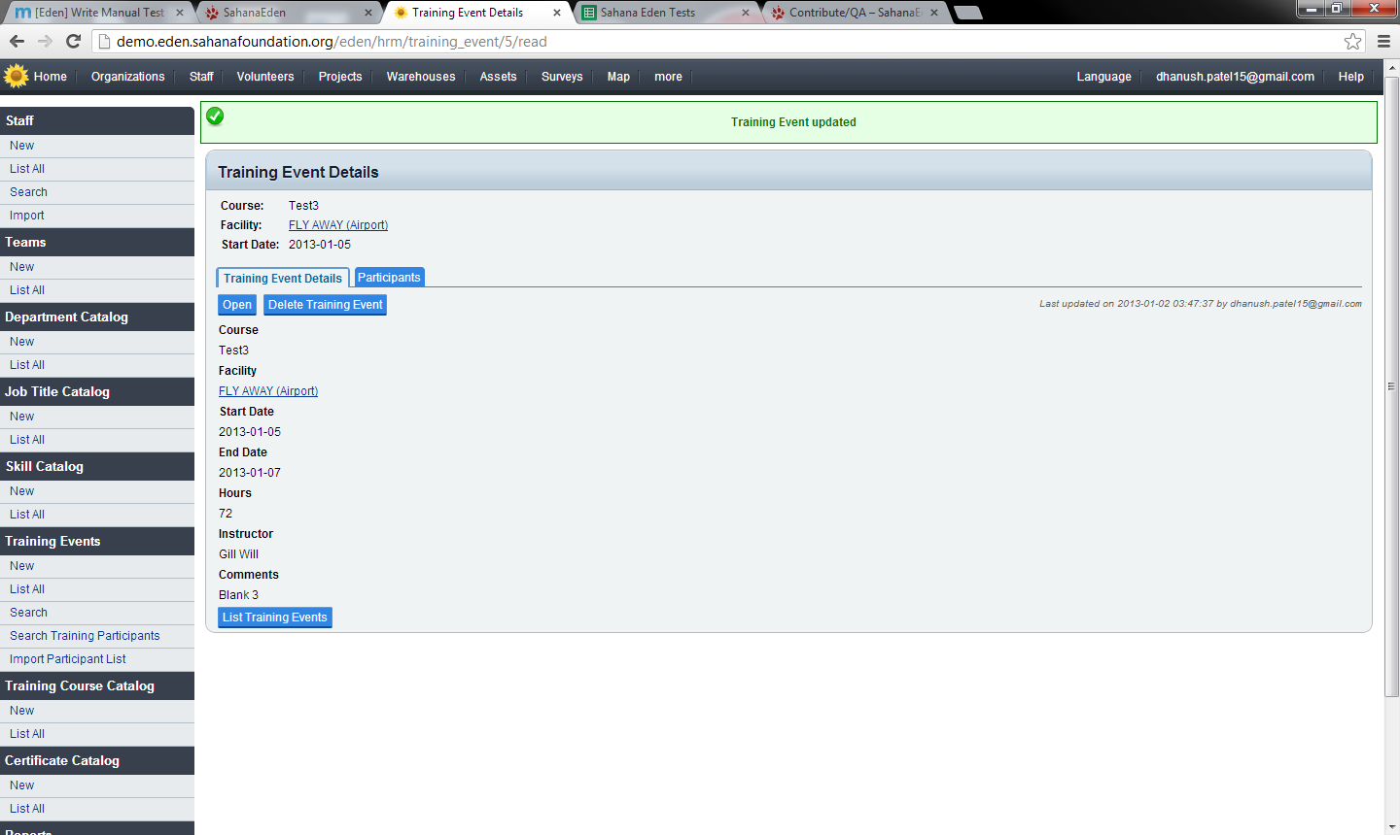
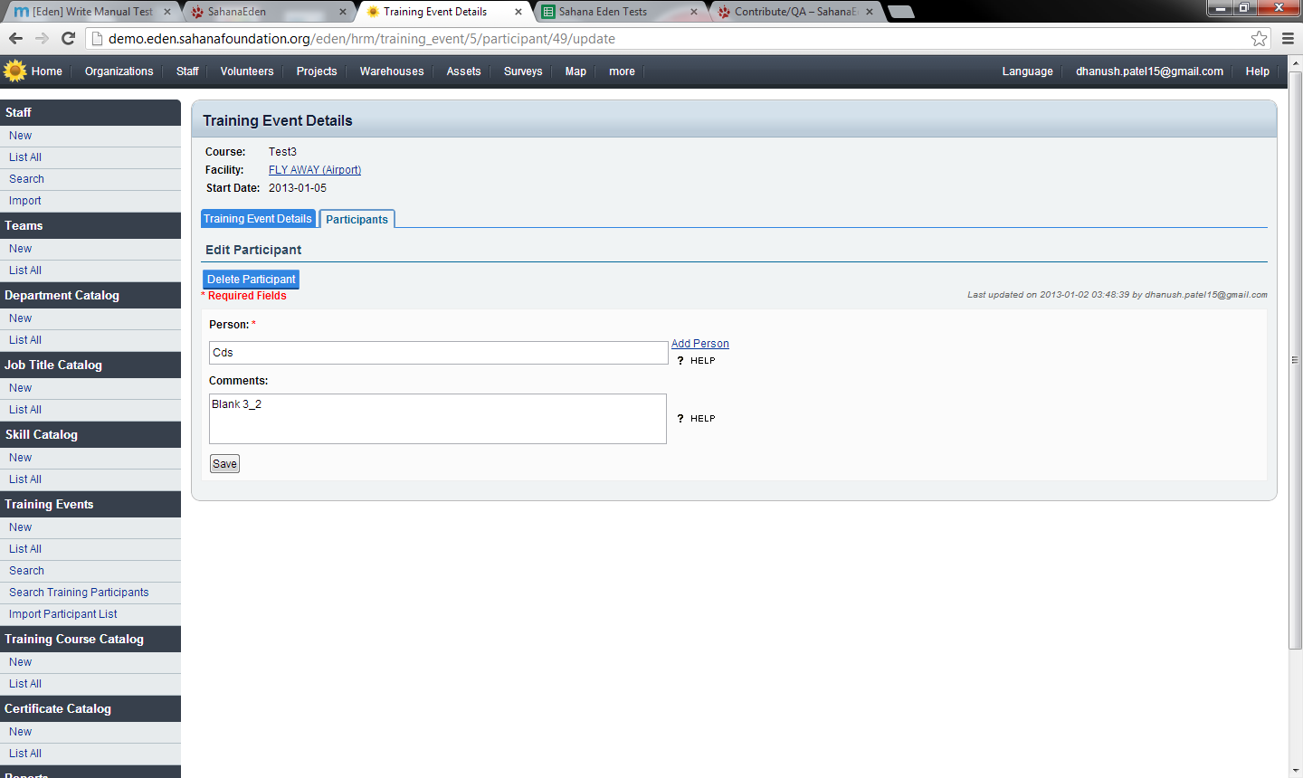
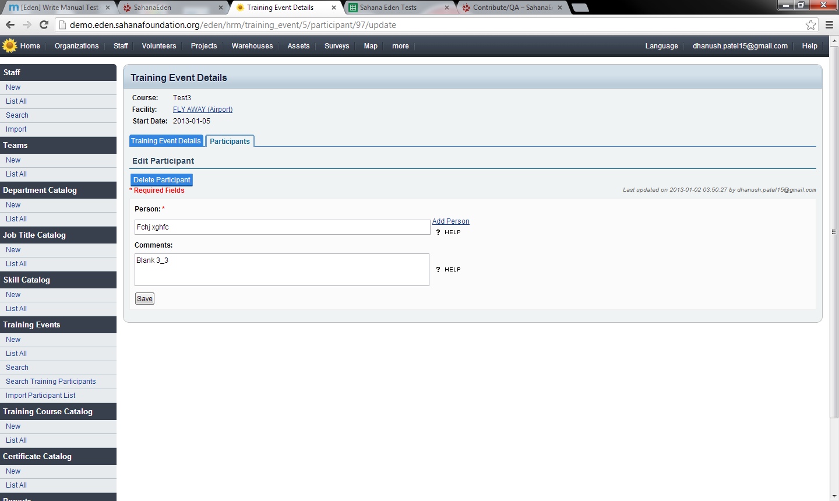
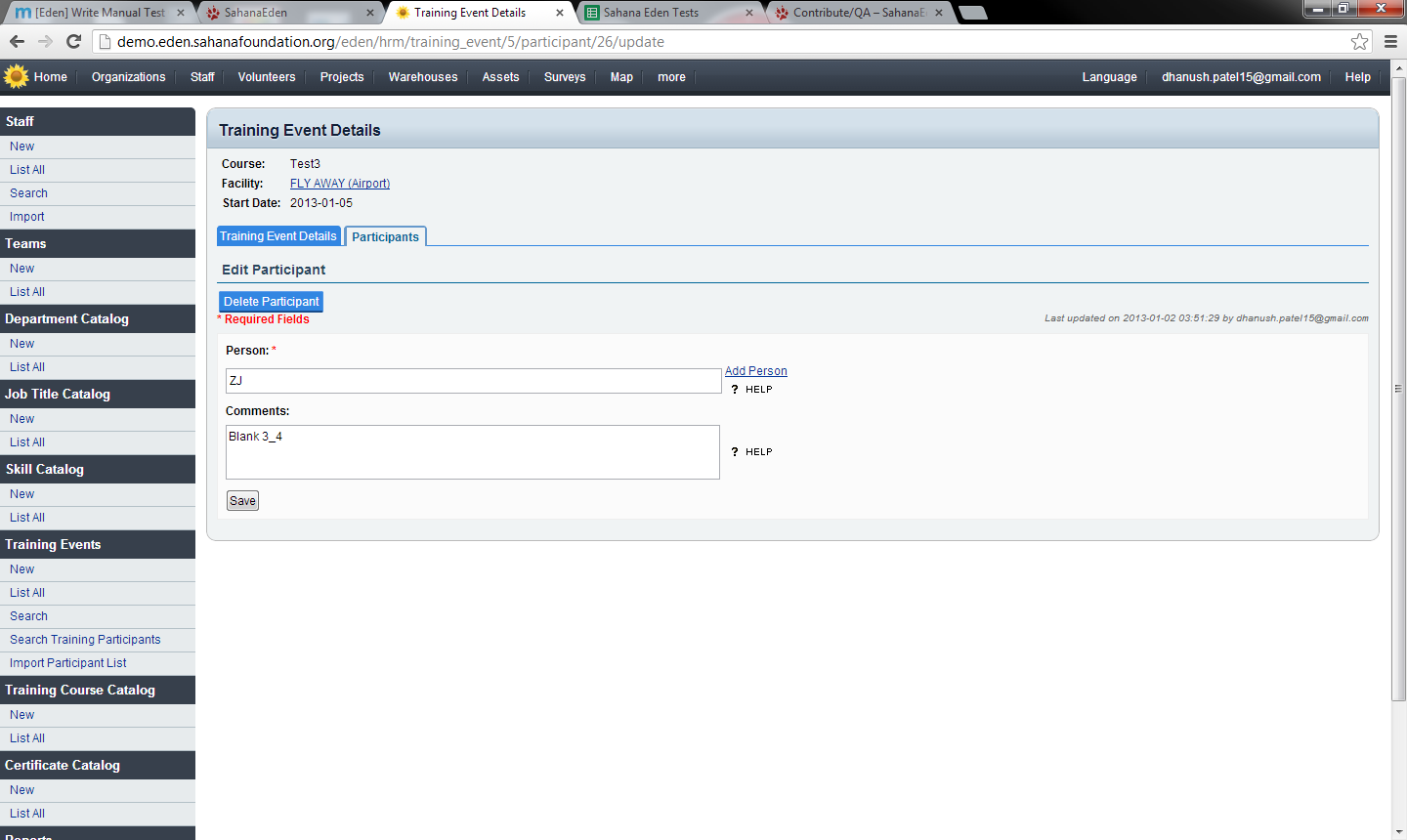

- Searching for 3 training events
  - 1st search, used; text: adas, facility: adas (hospital),
date: min: 2013-01-01 00:00 max: 2013-01-02 00:00
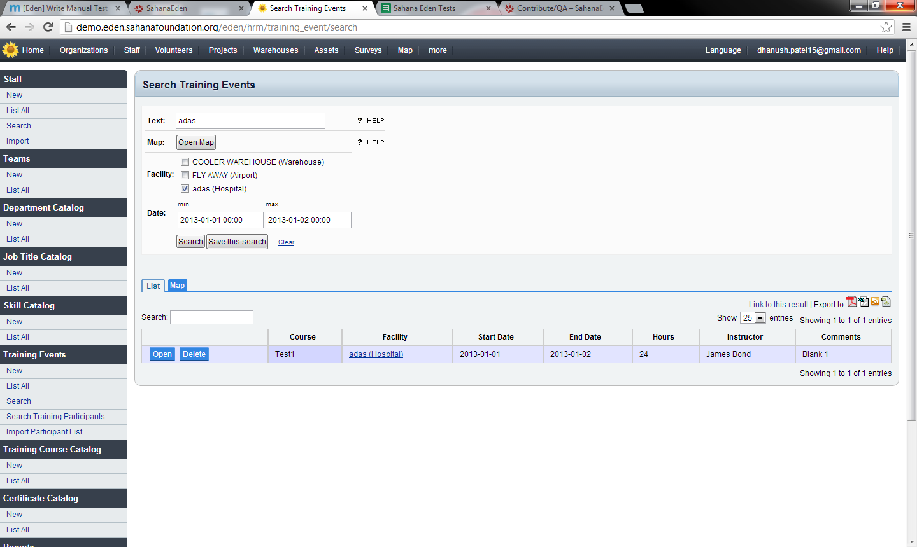
  - 2nd search, text: Blank 2, facility: COOLER WAREHOUSE (Warehouse)
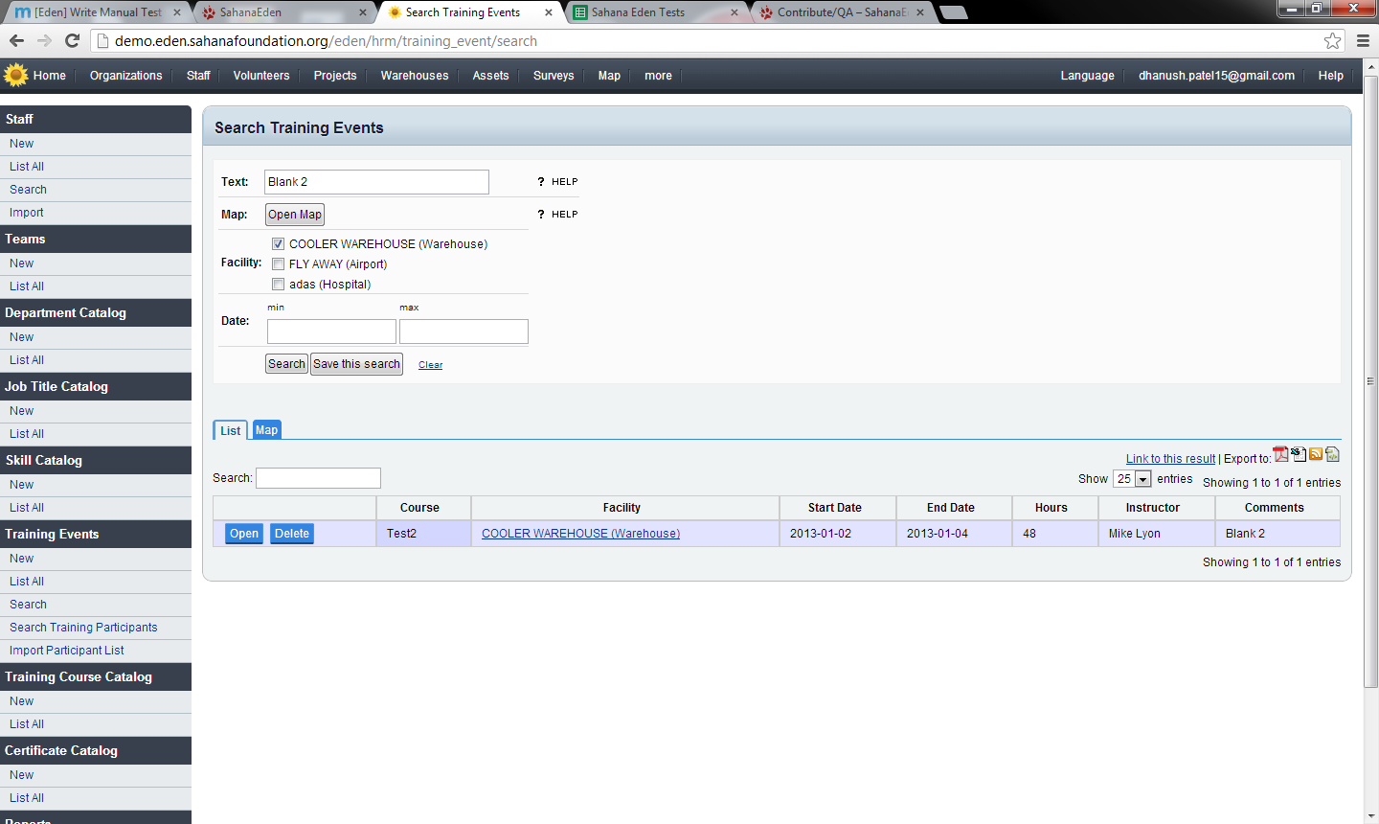

  - 3rd search, text: Test3, facility: FLY AWAY (Airport) 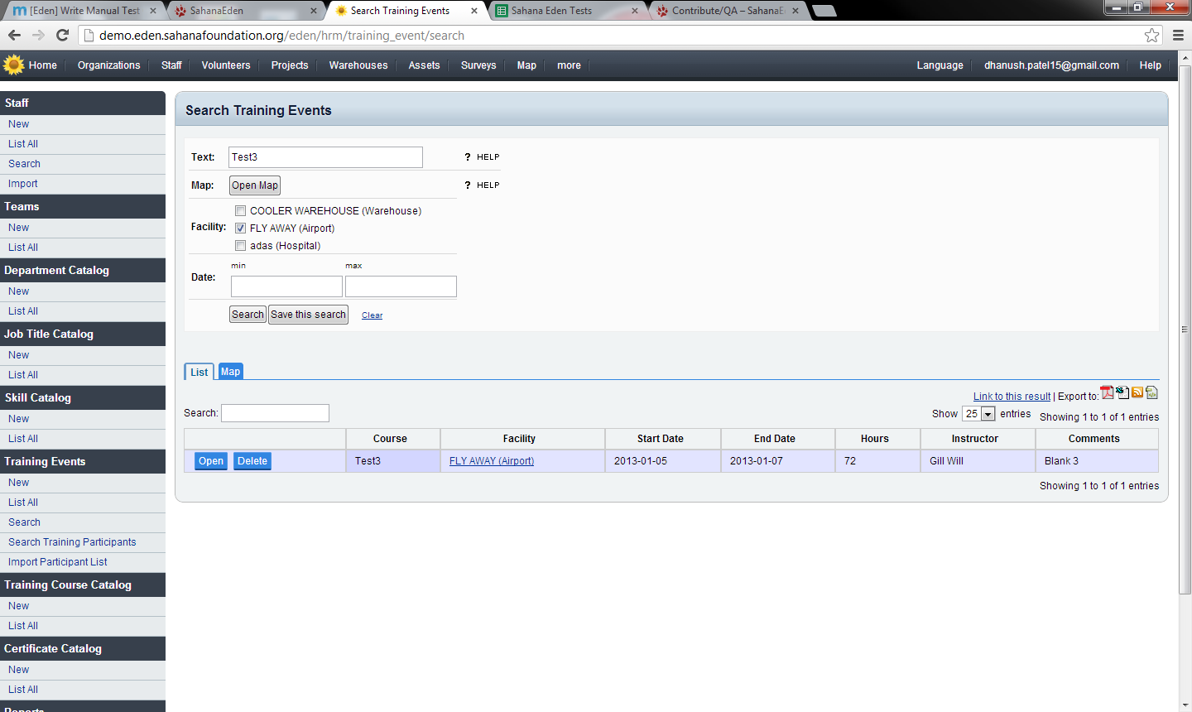
  - 4th search, text: Test
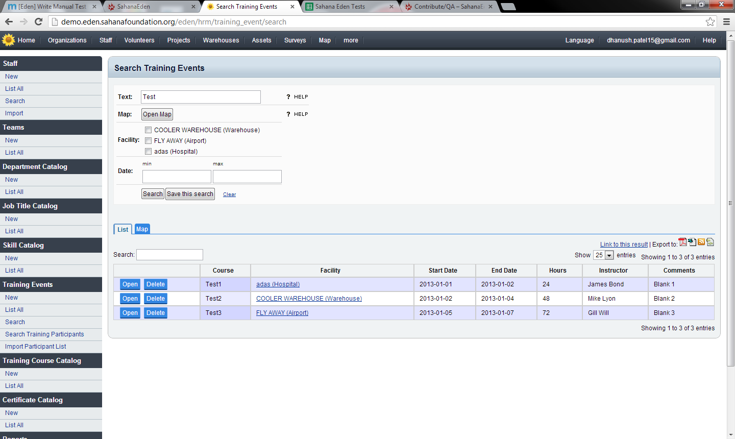
This concluded the writing of a manual test case for a Sahana Eden Module.

